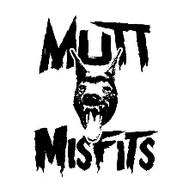 VOLUNTEER APPLICATION

Please read the information below carefully.

Name: ___________________ ______________________
First Last
Address: ___________________________, ________________________, _______, ________
Street City State Zip Code

Phone Number: _______________________ __________________________
Cell Number Home Number
Drivers License Number/State:____________________________________
Emergency Contact: _____________________________ _____________________
Name Phone Number

- Volunteer Activities I am interested in, please circle all interests:

Adoption Outreach Special Events Graphic Design Administrative

Fundraising Adoption Center Temporary Foster Adoption Meet & Greets

Other (Please Specify):_________________________________________________________

- My Availability
Weekday Mornings Weekday Afternoons Weekday Evenings Weekend Mornings
Weekend Afternoons Weekend Evenings My Schedule Varies

- Special Skills or Qualifications:

Release and Waiver of Liability

I agree that the information I have provided is wholly accurate and I have read and fully understand all terms contained within this application.
By executing this document it is my intent to forever discharge, release and hold harmless Mutt Misfits Animal Rescue Society and its Board of Directors, volunteers, agents or sub-contractors. I am fully aware that by submitting this document, I am releasing the above-mentioned parties from liability that may arise as a result of intentional or negligent acts of these parties relating to any accident and/or injures and/or death that may occur during the act of being a volunteer with/for Mutt Misfits Animal Rescue Society.
By signing this form, I certify that I am at least 18 years of age and fully understand this statement.

________________________________________ ____________________
Printed Name of Applicant /Volunteer Date

________________________________________
Signature of Applicant/Volunteer

________________________________________ ___________________
Printed Name of Mutt Misfits Representative Date

________________________________________
Signature of Mutt Misfits Representative

Muttmisfists/volunteer application/2020

